**Workflow Optimization - Manufacturing Sector**

GOKULNATH K & E24755

**Overview**

Workflow optimization in the manufacturing sector involves streamlining processes to improve productivity and reduce bottlenecks. Data analysts play a key role by analyzing production data, identifying inefficiencies, and recommending adjustments using tools like predictive analytics and real-time monitoring. They help in optimizing resource allocation, improving throughput, and minimizing downtime. The focus is on balancing efficiency, quality, and cost-effectiveness to enhance overall operational performance.

**Objective**

1. Enhance Productivity: Identify and reduce inefficiencies to improve overall production throughput.
2. Minimize Downtime: Use predictive analytics to forecast equipment failures and prevent production halts.
3. Optimize Resource Allocation: Ensure efficient use of labor, materials, and machinery to reduce costs.
4. Improve Workflow Efficiency: Streamline processes to eliminate bottlenecks and enhance process flow.
5. Ensure Quality Consistency: Monitor real-time data to maintain high product quality standards.

**Assigned Task(s)**

* Workflow Optimization - Manufacturing Sector.

**Task Details**

* **Task 33 :** Workflow optimization in the manufacturing sector involves analyzing data to streamline processes, reduce bottlenecks, and improve productivity. Data analysts use insights to enhance efficiency, minimize downtime, and optimize resource usage.
* **Status:** Completed.
* **Details:**

1. Designed a workflow_optimization table to track production metrics, including employee efficiency.
2. Added sample data for various production metrics to facilitate analysis.
3. Implemented queries in mysql to calculate employee efficiency and defect rates for analysis and reporting.
4. Created a bar plot to visualize the efficiency percentage of each employee.
5. Developed a line plot to show the defect rate per product, adding annotations for defect rates at each data point.
6. Utilized Seaborn for effective data visualization, enhancing clarity and understanding of performance metrics.

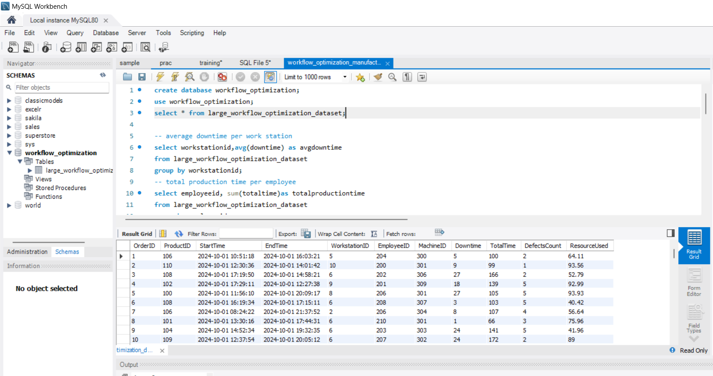

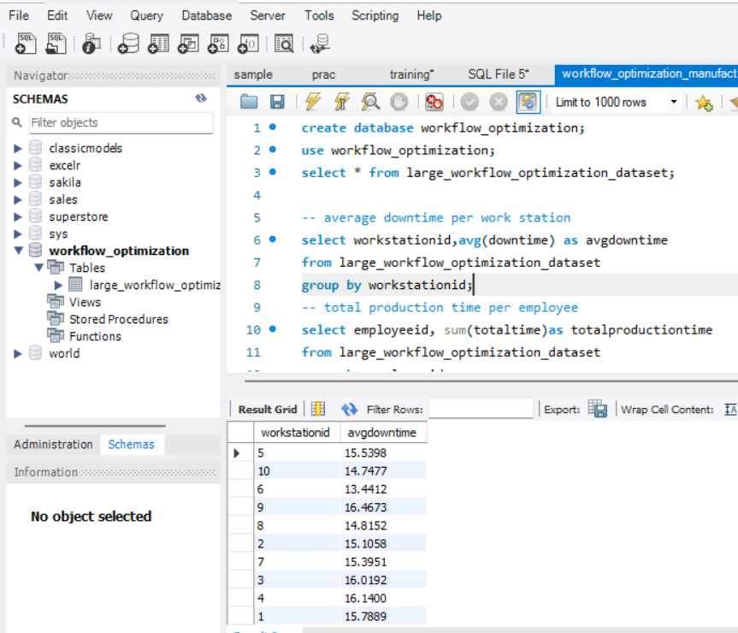

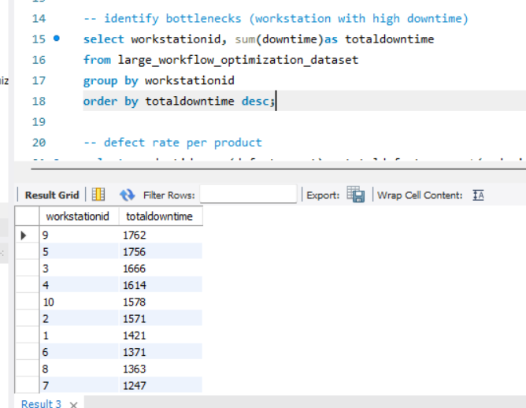

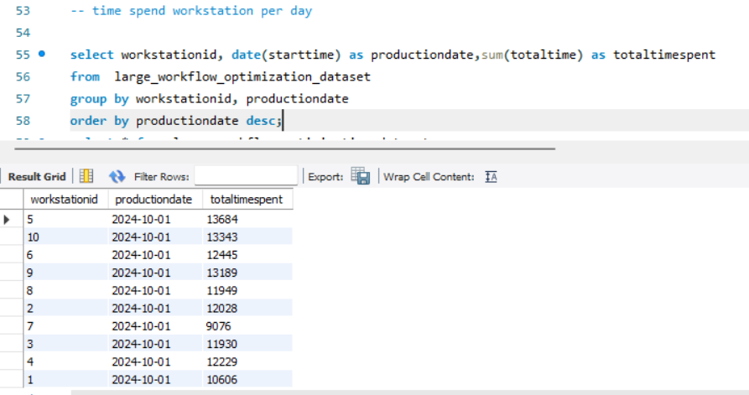

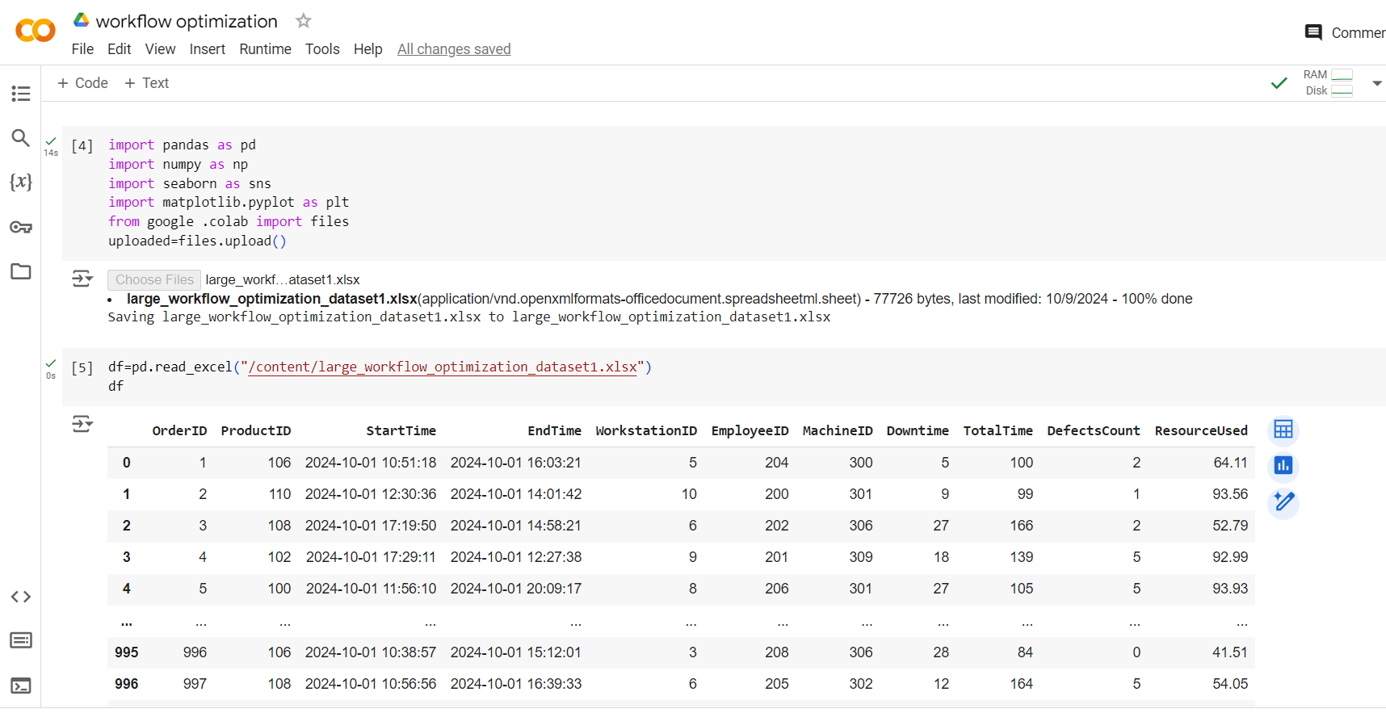

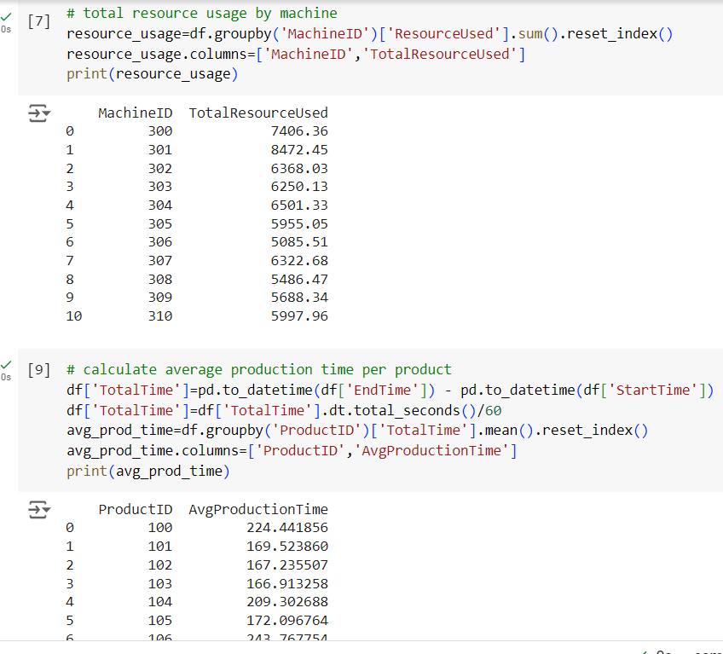

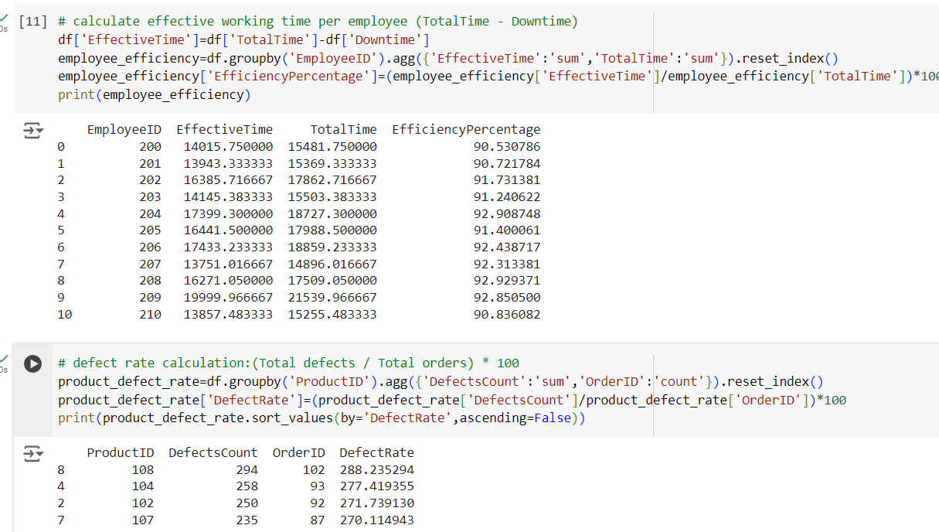

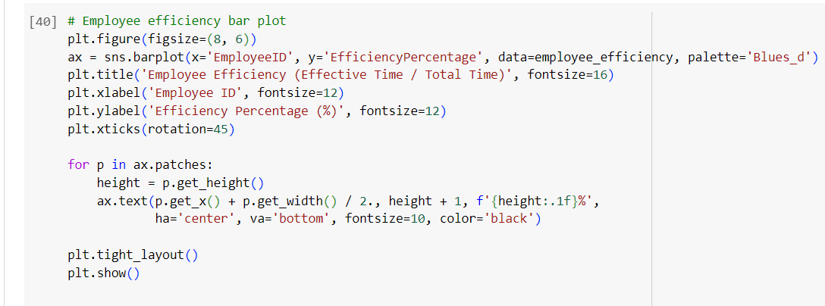

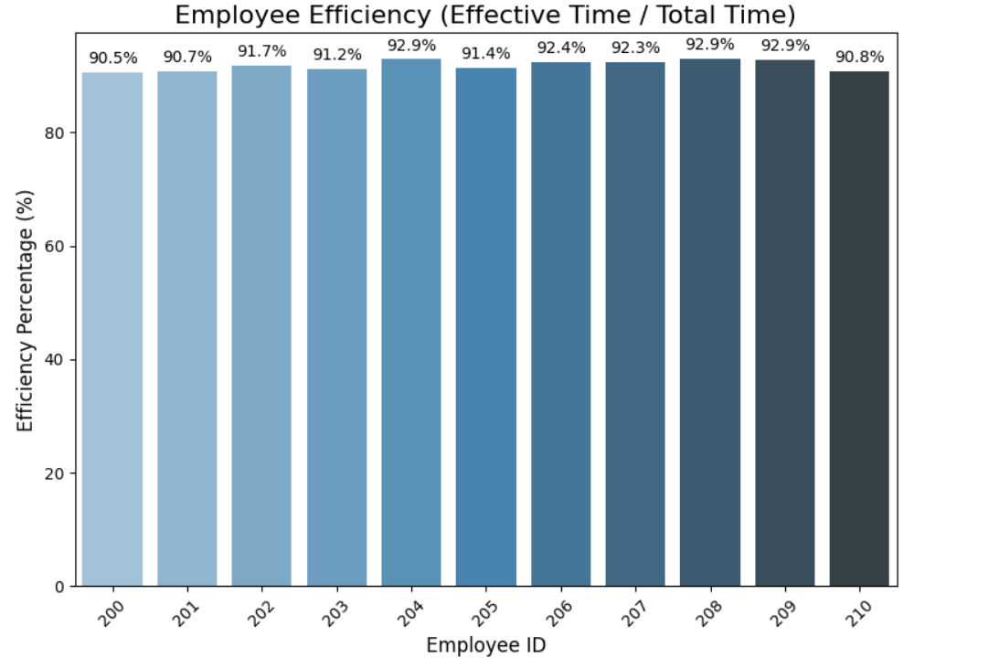

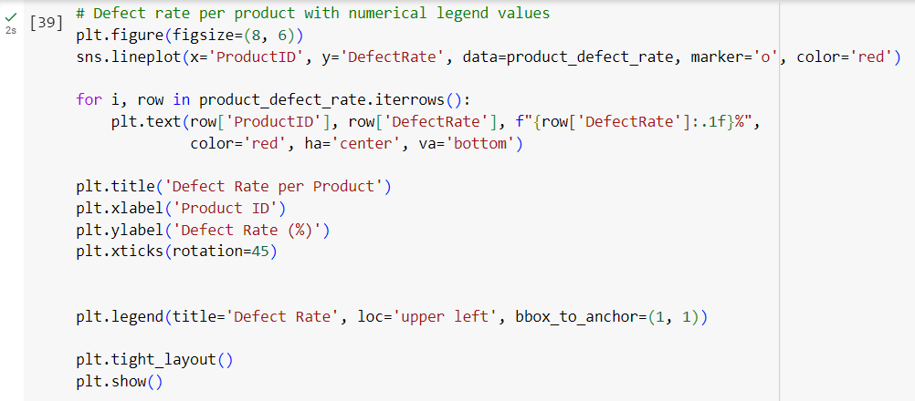

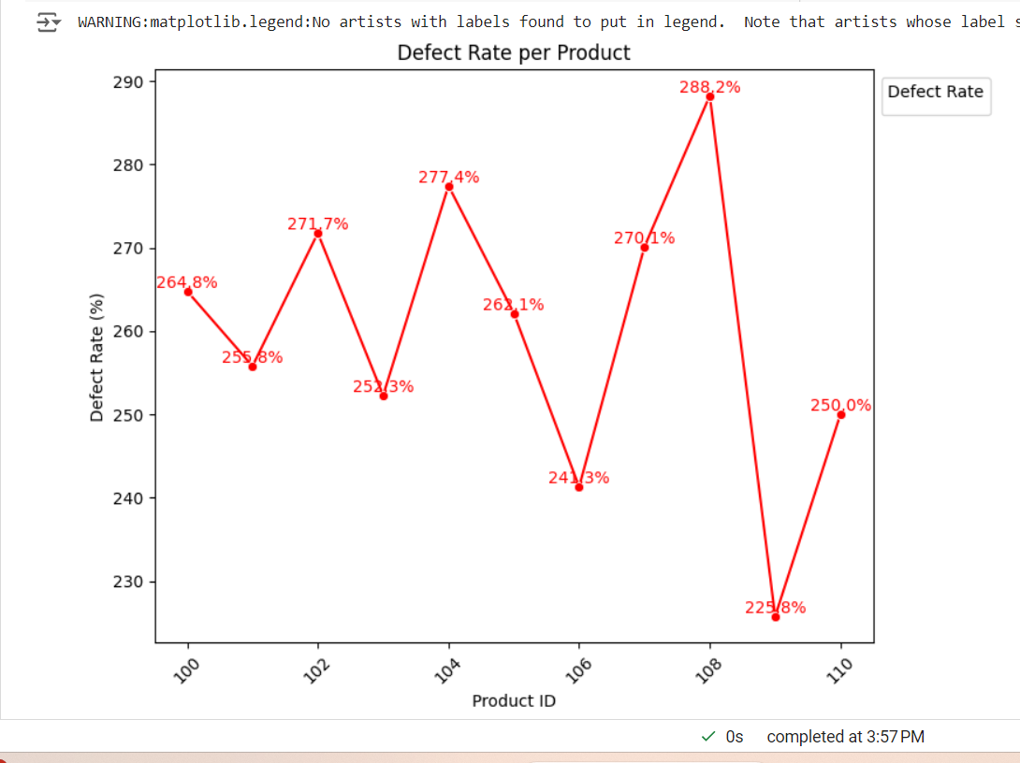

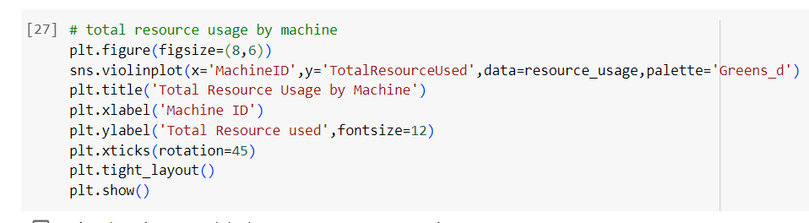

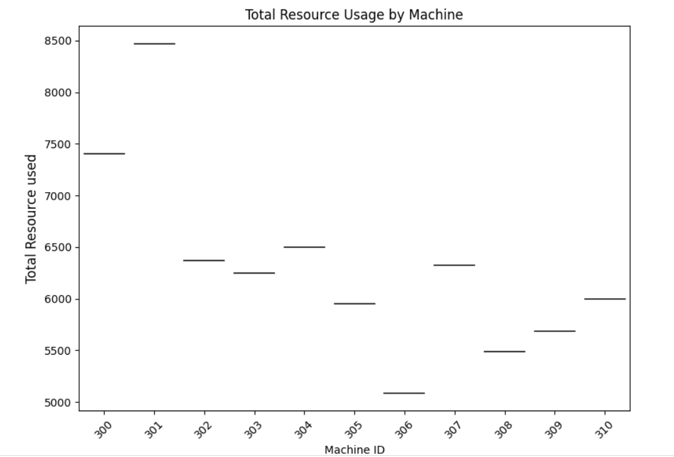

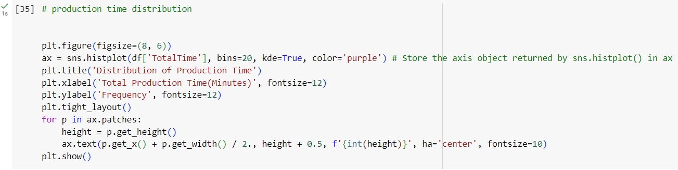

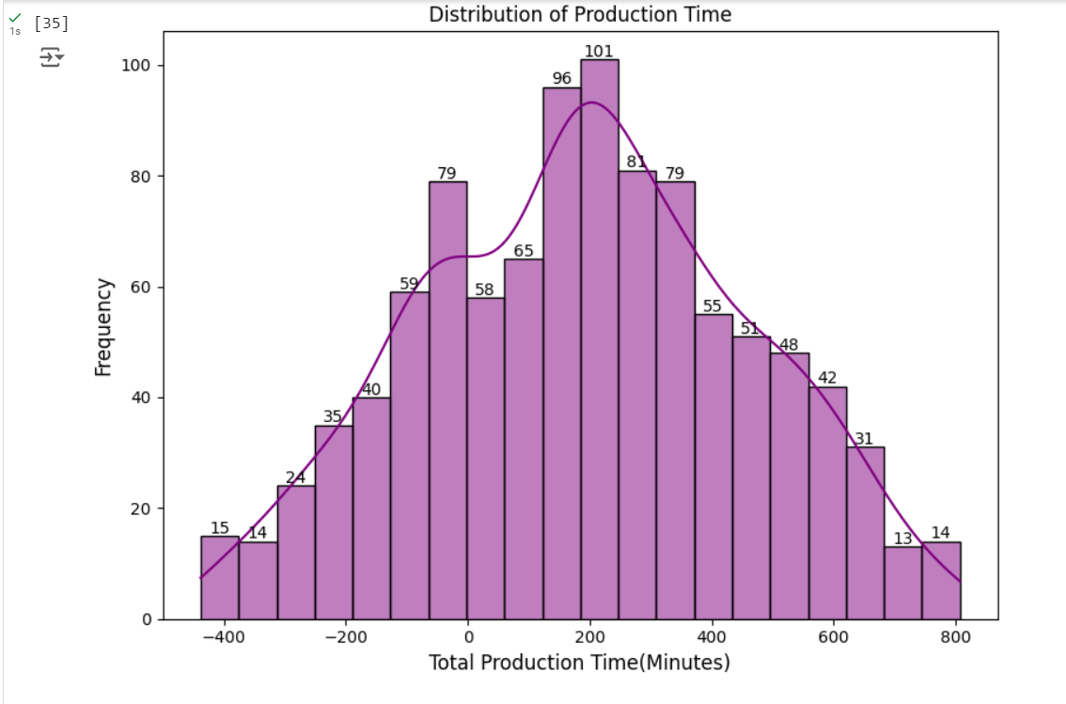

**Progress**

* **Accomplishments:**

1. Created a structured database to store workflow optimization data, enabling organized access to key performance metrics.
2. Successfully inserted sample records into the database to facilitate analysis of employee efficiency and defect rates.
3. Developed SQL queries to calculate and analyze employee efficiency metrics, enhancing insights into workforce productivity.
4. Generated a bar plot displaying employee efficiency percentages with clear numerical labels, making it easy to compare performance across employees.
5. Created a line plot to visualize defect rates per product, enhancing understanding of quality control and areas needing improvement.
6. Utilized visualizations to effectively communicate performance metrics, aiding in decision-making and strategic planning.

* **Metrics:**

1. Measures how effectively employees are utilizing their time in production (Effective Time / Total Time).
2. Calculates the percentage of defective products for each product line, providing insight into quality control.
3. Tracks the time spent on each production order, helping identify process bottlenecks.
4. Monitors machine downtime to assess equipment performance and its impact on production efficiency.
5. Measures the total resources consumed by each machine, ensuring optimal utilization and identifying overuse.

**Challenges and Solutions**

* **Challenges Faced:**

1. Creating clear visualizations from complex data.
2. Optimizing SQL queries for large datasets.
3. Handling complex relationships between employees, machines, and products.

* **Solutions Implemented:**

1. Utilized Seaborn and Matplotlib to design intuitive and insightful plots.
2. Improved query efficiency to handle high data volume without delays.
3. Designed a structured database schema to efficiently manage relationships.

**Next Steps**

* **Upcoming Tasks:** Approach upcoming tasks by continuously refining data accuracy, optimizing database performance, and leveraging advanced analytics to enhance decision-making and workflow efficiency.
* **Goals:** Achieve upcoming goals by aligning data-driven insights with strategic objectives, enhancing process optimization, and driving continuous improvement in manufacturing operations.

**Conclusion**

* **Summary:** The workflow optimization in the manufacturing sector enhances productivity by analyzing key metrics such as employee efficiency and defect rates. Leveraging SQL for data management and Python for insightful visualizations enables clear performance tracking and process improvement. Addressing challenges with structured data and optimized queries ensures continuous workflow enhancements and resource utilization.
* **Acknowledgments:** Thank you all for your attention and engagement, I appreciate your interest in the Workflow Optimization in Manufacturing sector.